SQL : SELECT DISTINCT cid,cname FROM Course

SQL2 : Select b.gid , b.gname ,a.cid , a.cname From Course a INNER JOIN [Assignment].[dbo].[Group] b ON a.gid = b.gid Where a.cid = ?

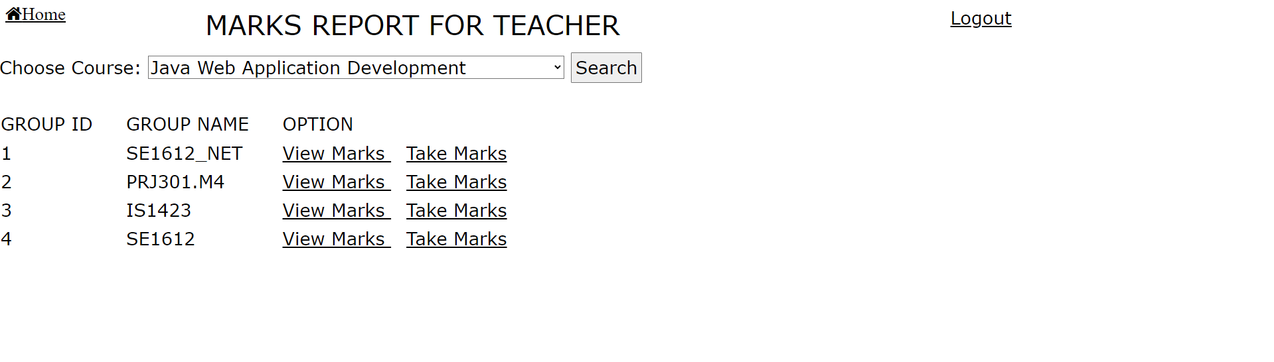

SQL : select a.sid, a.scode, a.sname, d.m1, d.m2, d.m3, d.m4, d.mfe

from Student a INNER JOIN [Assignment].[dbo].[Group] b ON a.gid = b.gid

INNER JOIN Course c ON c.gid = b.gid

INNER JOIN Marks d ON a.sid = d.sid AND b.gid = d.gid

AND c.cid = d.cid

WHERE b.gid = 1 AND c.cid = 1

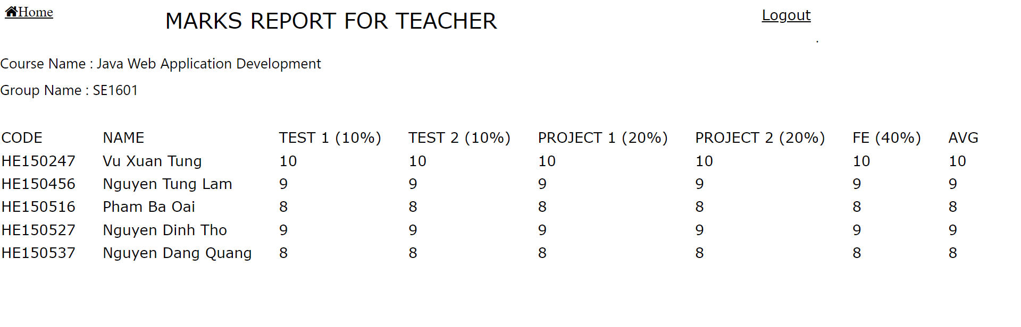

SQL : UPDATE Marks SET m1 = ? , m2 = ? , m3 = ? , m4 = ? , mfe = ? WHERE mid = ?

